

Small project {midterm}

CS222 :COMPUTER ARCHITEURE

Name project {BANK}

STUDENTS NAMES :

1. AHMED SAID MOHAMED ALI
2. AHMED ATEF AHMED MAHMOUD
3. AHMED SAMI AHMED ABDULLAH

SECTION : 2

# 1)

|  |  |
| --- | --- |
| Input | Description |
| **clk** | You will take this clock from fpja |
| **tcount** | You will take it from two switchs and Tcount will take {01,10,11} |
| **d** | You will take it from push button |
| **sw** | It will be responsible for increment and decrement if (sw) =1 the counter will increment  if (sw) =0 the counter will decrement |
| **reset** | You will take it from switch |

|  |  |
| --- | --- |
| Output | Description |
| **led** | It will display the number of pcount |
| **led2 , led3** | It will display the wtime |
| **full** | It will show you if pcount is full If(pcount =7)  full = 1 else  full =0 |
| **empty** | It will show you if pcount is empty If(pcount =0)  empty = 1 else  empty =0 |
| **Alarm** | If pcount =7 and you countiue increment or If pcount =0 and you countiue decrement  Alarm will equal 1 |

**2)**



[6:0]led3

reset

[6:0]led2

sw

[6:0]led

d

Alarm

[1:0] tcout

empty

clk

full

BBqM

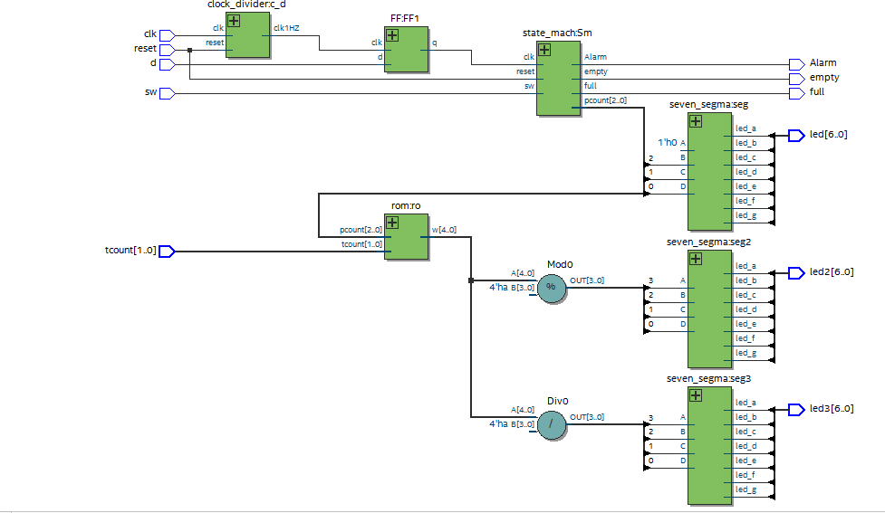

# 4)



S0

pcount =0

S1

pcount = pcount+1

S2

pcount = pcount-1

sw=0 clk =1

sw=1 clk =1

sw=0 clk =1

sw=1 clk =1

sw=1 clk =1

reset

* **test bench to state_machine**

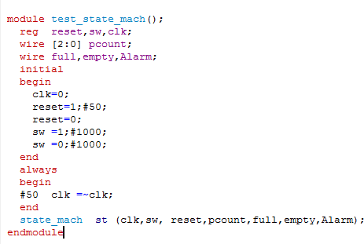

* **Simulation to state_machine**

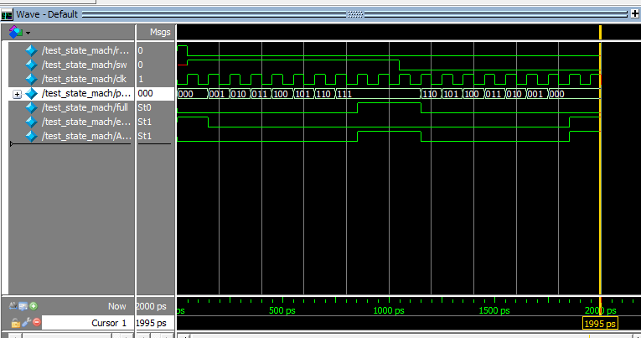

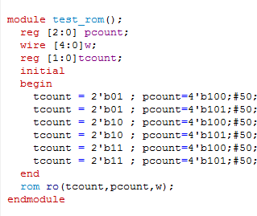

* **Simulation to state_machine**

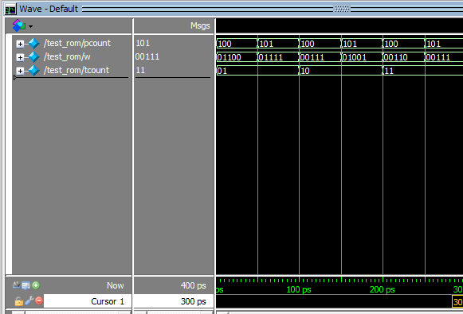

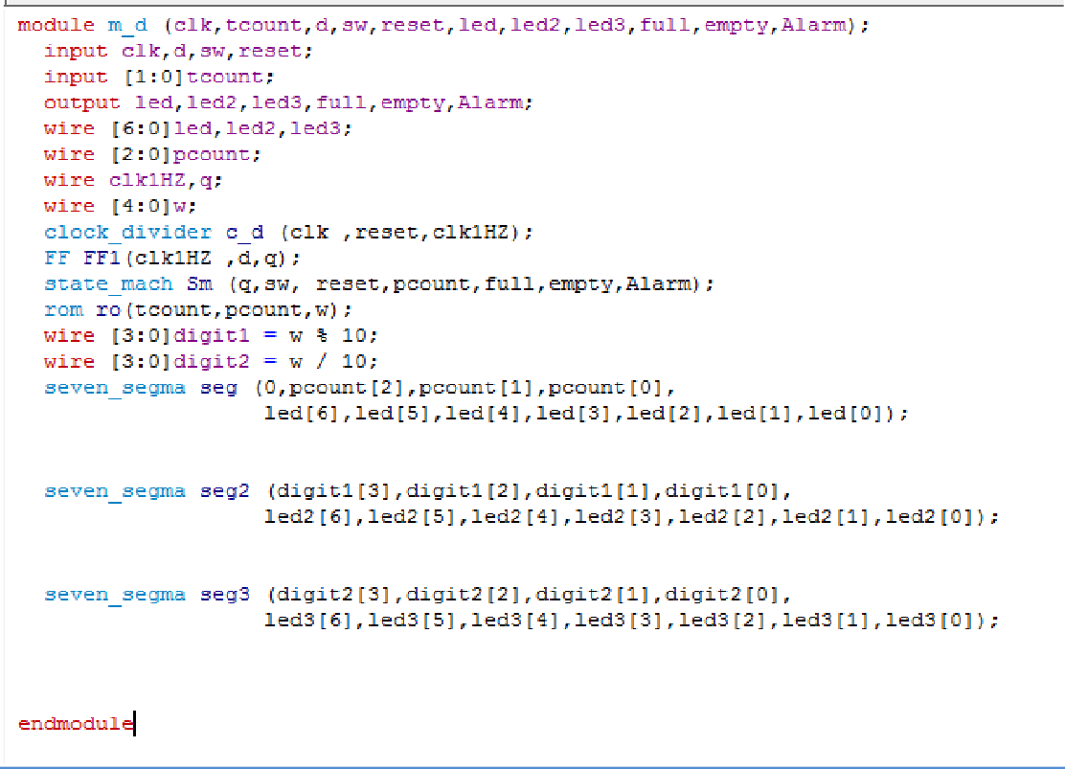

* **Simulation to Top level module**

